# CS-340 Project Two README

## About the Project

This project allows the user to view and interact with animal data in the database. Users can interact directly with the data table to filter results or utilize the buttons to sort for animals that meet the criteria for Water Rescue, Mountain/Wilderness Rescue, or Disaster/Individual Tracking. Users can also interact with the geolocation chart to view the location of the selected animal. Users can also view a pie chart displaying the breakdown of breeds being displayed in the data table.

## Motivation

This application was created for Grazioso Salvare to help identify dogs that would be good candidates for search-and-rescue training. A non-profit agency which operates animal shelters in the Austin, TX area has provided data for use with the application.

## Getting Started

* Install Python, PyMongo, MongoDB, and Jupyter if they are not already installed.
* Import the data (“aac_shelter_outcome.csv”) into MongoDB.
* Create a user account in MongoDB to access the database.
* Modify the Data Manipulation/Model section of “ProjectTwoDashboard.ipynb” to match your MongoDB configuration including username, password, host, port, database name, and collection name.
* Run the “ProjectTwoDashboard.ipynb” file.

## Installation

This project utilizes the following software:

Python 3.9.12

PyMongo 3.12.0

MongoDB 6.0.13

Jupyter 6.4.8

## Usage

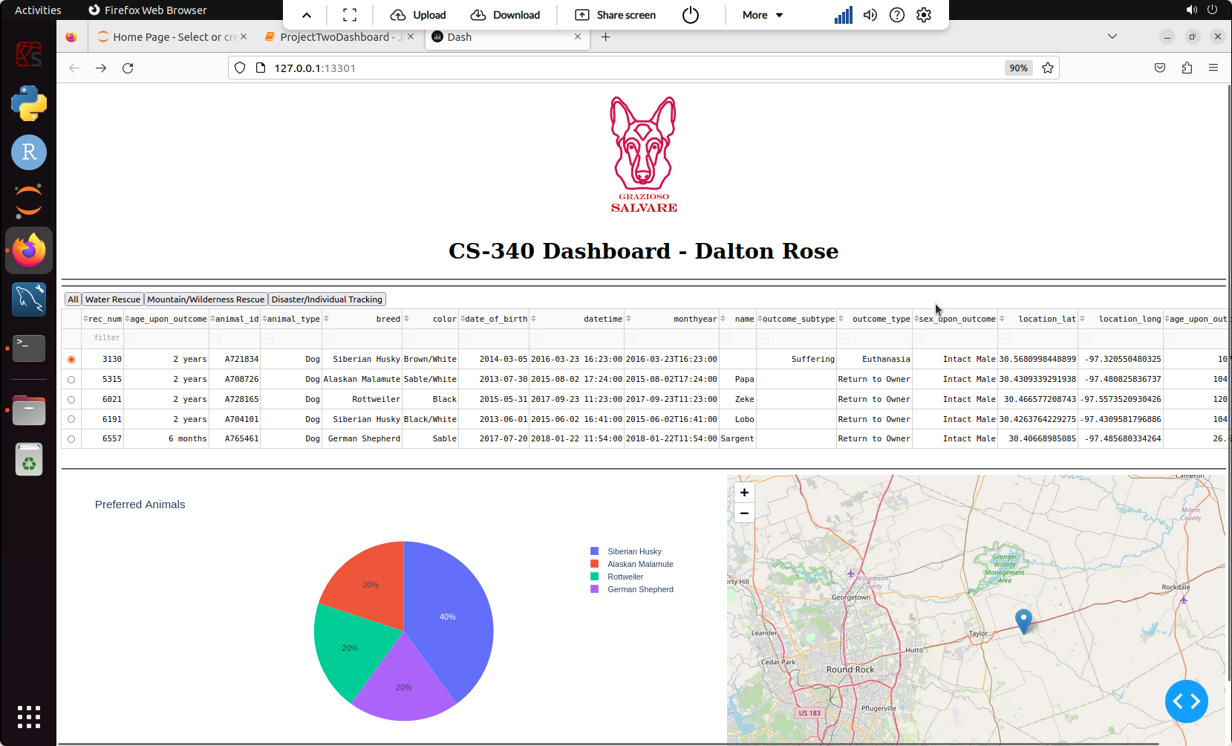

## Dashboard Homepage, with interactive data table at the top, pie chart on the bottom left, and geolocation chart on the bottom right.

**Tools**

MongoDB was used because it enables us to handle large amounts of data and search that data using detailed queries. PyMongo is a tool that allows us to more easily interface with the MongoDB database. Using PyMongo, I developed the AnimalShelter software which powers the dashboard and enables us to perform CRUD (create, read, update, and delete) operations on documents in the MongoDB database. Dash is a Python framework which enabled us to quickly development a web application to view and interact with the data in our database.

**Challenges**

I faced several challenges while developing this application. At the beginning of this course, I had no knowledge of MongoDB, PyMongo, or Dash. Throughout this project, however, I was able to gain a better understanding of these tools with the help of the textbook and official documentation. Overall, I think I did a good job of building a functional web application dashboard. However, there are a few minor issues that I was not able to fix in time. For example, when the entire dataset of animals is shown, the pie chart shows too much data to be useful. Additionally, when a filter is selected with the buttons, there is no indication of which filter is currently selected.

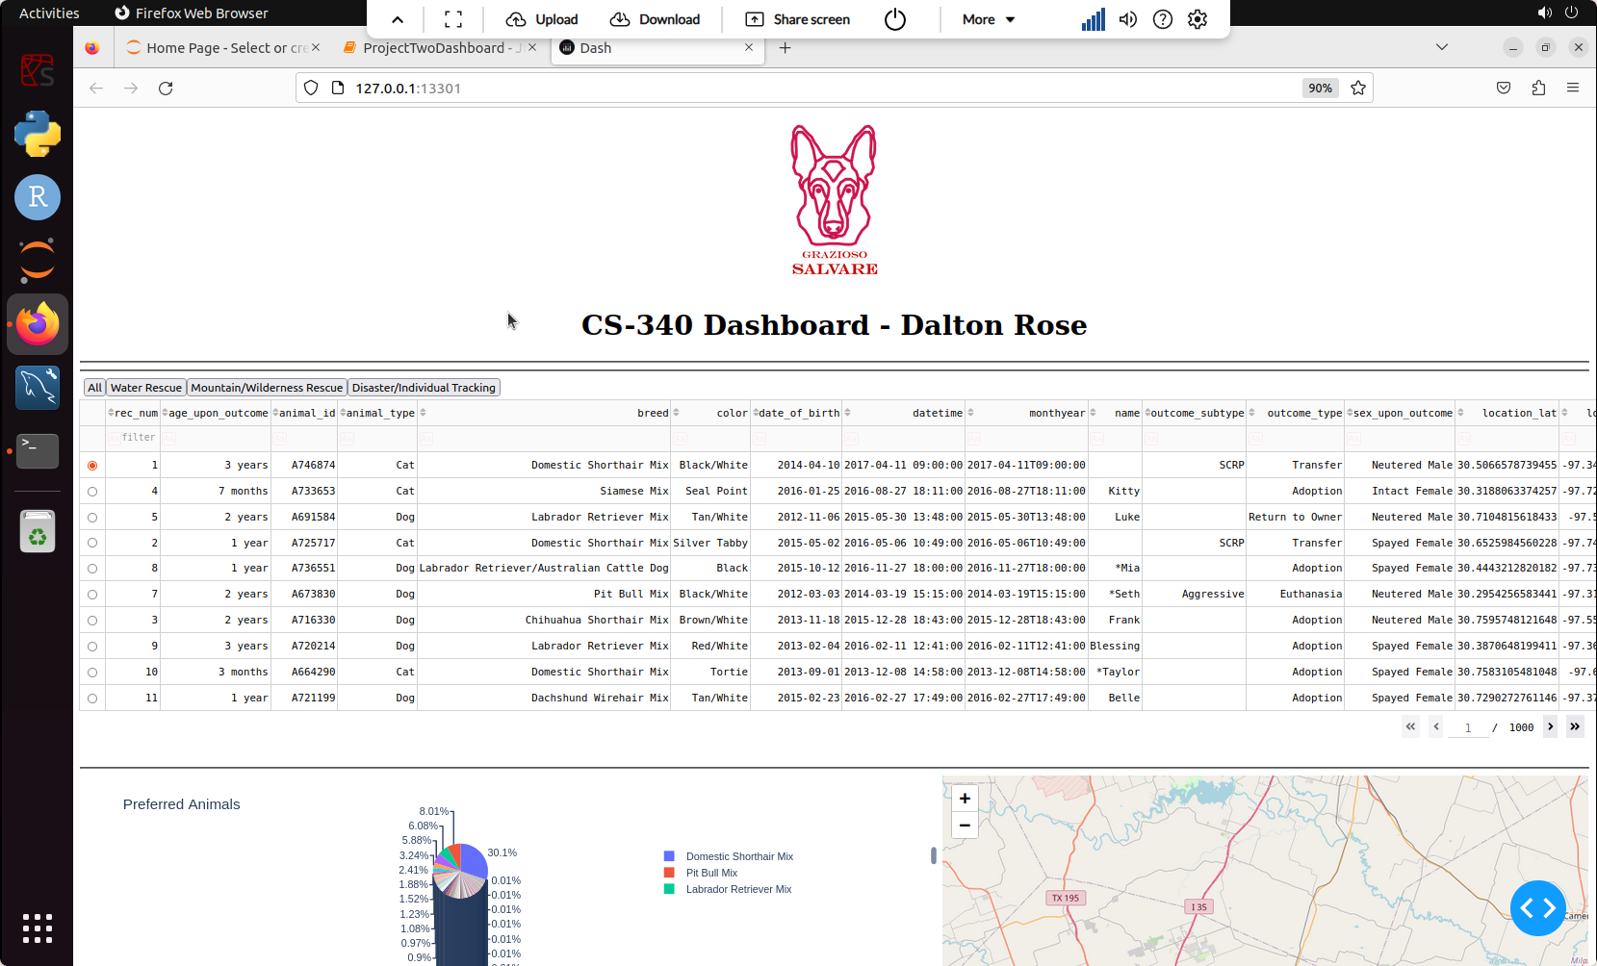**Additional Screenshots**

**No Filter Selected**

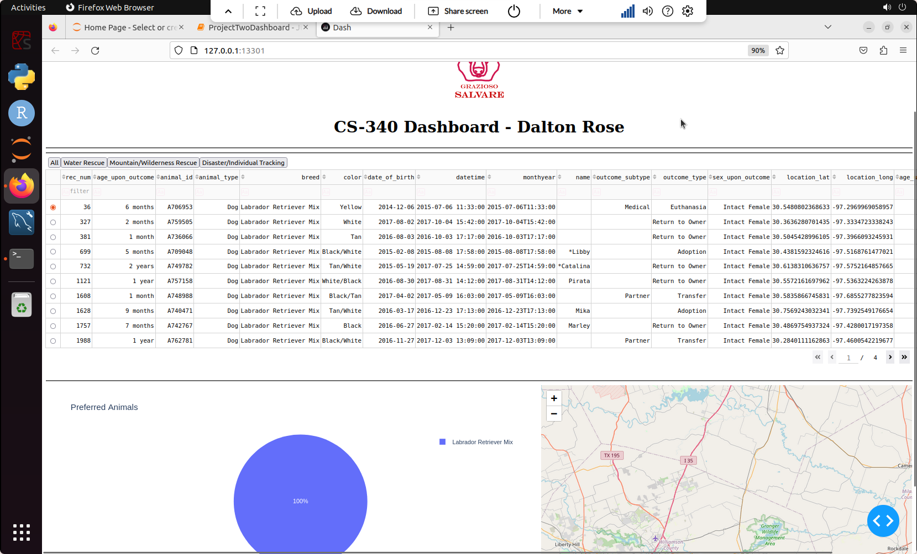

**Water Rescue Filter Selected**

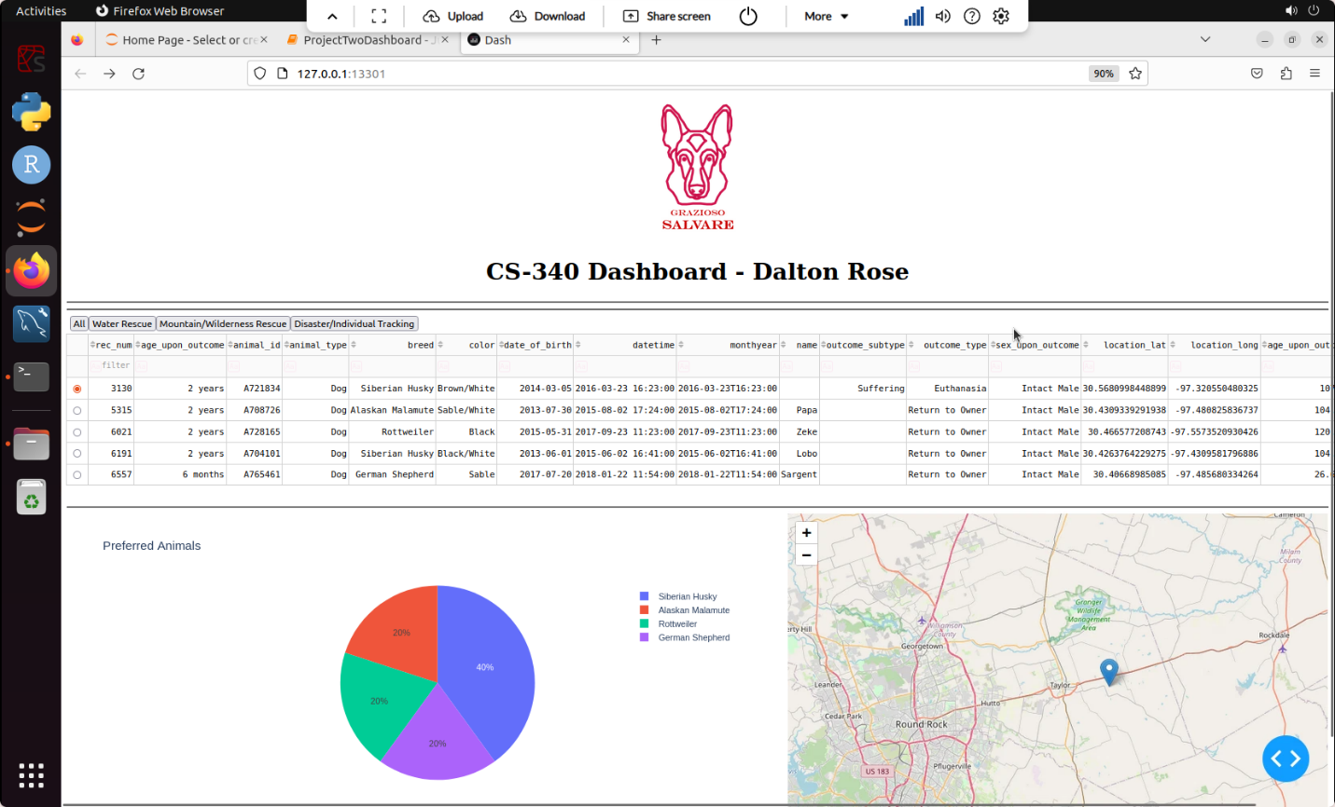

**Mountain/Wilderness Rescue Filter Selected**

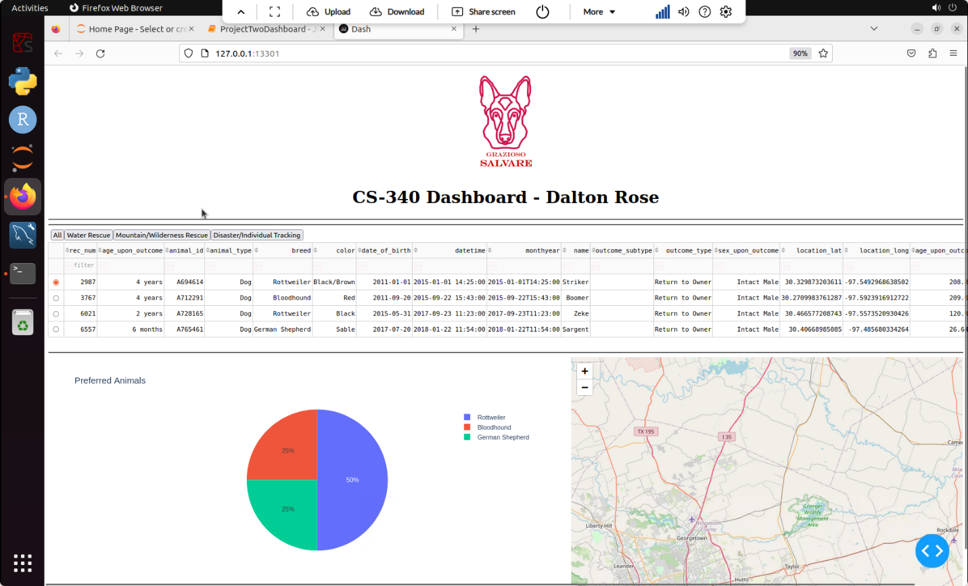

**Disaster/Individual Tracking Filter Selected**

## Contact

Dalton Rose

dalton.rose@snhu.edu